**Understanding your waste stream**

Before committing to investing in an organics collection scheme, it is obviously important to assess how much waste might be diverted from landfill as a result. This information can then be used to calculate potential benefits and cost-effectiveness, and help shape the scope and design of the scheme.

**How much food and garden organics are available?**

A ‘typical’ Australian household garbage bin is made up of the following materials by weight:

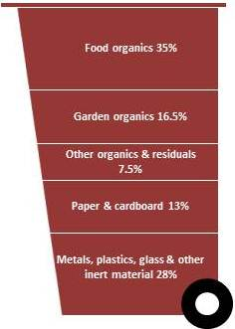

*Garbage mix type (NGER technical guidelines, 2011)*

The percentages listed above are for an ‘average’ household garbage bin and indicate that over 50% is food and garden organics, with food being the single largest component, approximately 35% by weight. In 2006–07 an estimated 2.7 million tonnes of household food organics were disposed to landfill across Australia.

The amount of garden organics in the garbage bin depends on a range of factors, especially whether a garden organics collection service is available. On average, household garbage comprises around 17% garden organics which in 2006–07 equated to an estimated 1.3 million tonnes of garden organics disposed to landfill across Australia.

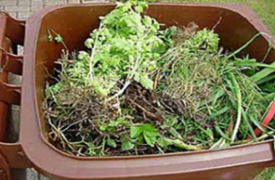

*Garden organics (Hyder)*

**Australian waste data**

Waste audits are the most common way of finding out how much food and garden organics are contained in household garbage. The [*National Food Waste Assessment*](http://www.environment.gov.au/wastepolicy/publications/pubs/food-waste.pdf) *Report* (2011) provides substantial information about existing waste audit resources held by auditing consultants and councils, or regional waste management organisations. While significant numbers of residential waste audits were identified by this assessment, the report does not provide a comprehensive collation of this audit data across Australia.

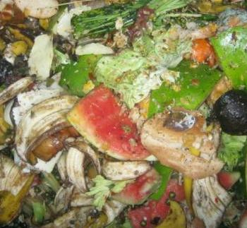

*Food organics (Hyder)*

Increasing numbers of household-level audits are being undertaken in Queensland and Western Australia, although the largest number of audits to date has been undertaken in NSW, South Australia and Victoria. The most reliable data on household level waste auditing may be found in South Australia and NSW, where consistent methodologies for undertaking such audits have been in place for longer periods.

**National Waste Report**

[*The National Waste Report*](http://www.ephc.gov.au/taxonomy/term/89) (2010) documents the current status of, and emerging trends in, resource recovery and waste management in Australia for each jurisdiction. The report covers

* Municipal solid waste (MSW)
* Commercial and industrial waste
* Construction and demolition waste
* Hazardous waste.

The report contains national municipal organic waste data from 2006–07, the most up-to-date national dataset available when the report was prepared, but it does not contain state-specific data. The report provides an approximate food organics generation rate per household across Australia.

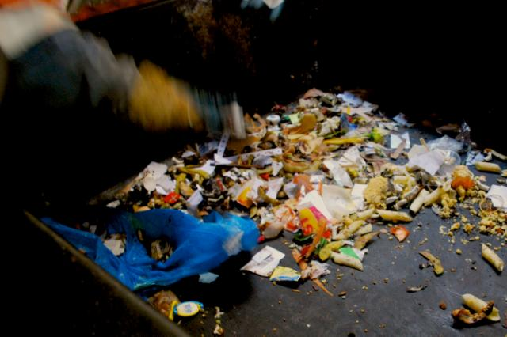

*Waste audit (Hyder)*

**Household waste audits in New South Wales**

NSW councils in the Sydney Metropolitan Area (SMA) and Extended Regulated Area (ERA) carried out household residual waste audits as part of the Waste and Sustainability Improvement Payment (WaSIP) program in 2007–08. The audits were conducted using a consistent NSW Audit Methodology, and included audits of household residual waste bins as well as recycling and garden organics, where appropriate.

The results of statistical analysis of the waste audit data are available in the [*Report on the Results of Waste Audits of Household Kerbside Collection Systems 2007–08*](http://aus.hybis.info/Projects0/VC/Awarded/AA004813/F_Reports/Factsheets/During%202007-2008,%20councils%20in%20the%20Sydney%20Metropolitan%20Area%20(SMA)%20and%20Extended%20Regulated%20Area%20(ERA)%20carried%20out%20a%20household%20resid)*.* The report shows the average residual bin in the SMA/ERA contains 40% food organics and 11% garden organics, although it also shows variation between each council area, and between single-unit dwellings (SUDs) and multi-unit dwellings (MUDs).

**Household waste audits in Victoria**

Sustainability Victoria conducted a one-off audit of the composition of MSW across four metropolitan Melbourne councils in 2008, with results presented in the [*Kerbside Garbage Composition: Recent Findings*](http://www.sustainability.vic.gov.au/resources/documents/Kerbside_Garbage_Composition_Recent_Findings21.doc) report. Sustainability Victoria also reviewed bin audits conducted by metropolitan Melbourne local governments from 2005 to 2007 in order to supplement these findings.

The audits found almost 50% of the garbage bin content was made up of organics, with more than 40% of this being food organics. The local governments with a two bin system had approximately 15% garden organics in their garbage bins, whereas for local governments with a three bin system 5% of the garbage bin comprised garden organics.

**Usability of default data**

It is not advisable to rely on national or state and territory data when planning an organics collection scheme because different amounts of organics are generated by different sectors of the community. Area specific compositional analysis will provide a more accurate picture of the available organics, and enable the quantity per household produced to be more accurately estimated for a specific council area.

**The waste audit process**

Conducting a waste audit is the first necessary step in any serious attempt to quantify and reduce waste – **“you can’t manage what you don’t measure”.**

Waste audits can be used to gather critical information to help achieve the best outcome from an organics collection system. A garbage bin audit, including a waste composition analysis, can provide a breakdown of the amounts and types of organics wasted and help you to understand the composition of waste going to landfill, and what could be recovered for recycling or composting.

Agreeing to follow a standard audit methodology is a good way to encourage trust between various stakeholders who may rely on the audit results for making decisions. For example, many councils have maximum contamination rates specified in their contracts with private sector processors of organics. If all relevant parties have access to an agreed, reliable data set, it will be easier to negotiate issues related to system performance in and open and transparent way, which will ultimately help deliver the best overall result from the system in place.

Until very recently, there have not been clear guidelines for undertaking residential kerbside auditing in most states and territories, with South Australia and NSW notable exceptions. Despite variability in audit methodologies, the increasing number of physical audits that have been undertaken in the past three to five years are likely to provide a valuable base of information about the character of Australian domestic waste, as well as the quantity of food and other organics present in this waste stream.

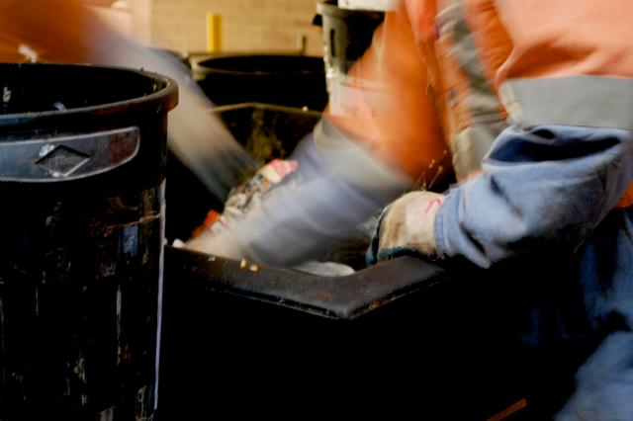

*Waste audit (Hyder)*

The [*Guidelines for Conducting Household Kerbside Residual Waste, Recycling and Garden Organics Audits in NSW Local Government Areas*](http://www.environment.nsw.gov.au/resources/warr/0846KerbsideAuditsJune.pdf) outlines key issues and methods for auditing household waste streams. The guidelines promote a consistent waste audit methodology and reporting framework for measuring the quantity and composition of average household residual waste and/or recycling and/or garden organics bins at the kerbside, and provide councils with the basis for reporting and evaluating their own overall performance as well as programs, sector and waste stream performance.Sustainability Victoria’s [*Guidelines for Auditing Kerbside Waste in Victoria*](http://www.sustainability.vic.gov.au/resources/documents/KerbsideWaste_V5.pdf) are intended to be used by councils and their contractors in planning and carrying out physical audits of household garbage, recyclables and organics collection services. The guidelines are for weight-based physical audits where materials are manually sorted and weighed according to categories of materials types. The intent of the guidelines is to promote greater standardisation of future audits, allowing councils to compare the performance of their waste and recycling management systems over time, and with other councils. The guidelines were developed in consultation with councils and waste auditing businesses in order to develop an audit methodology that cost-effectively produces accurate and useful data and information.

Zero Waste South Australia (ZWSA) has also developed a standard methodology for conducting kerbside waste and recycling audits, included in the [*Guide to Kerbside Performance Reporting*](http://www.zerowaste.sa.gov.au/upload/kerbsidereporting/ZER3606281%202007%20GUIDE%20TO%20KERB.pdf). ZWSA also offers a comprehensive program of training and support to councils and their consultants, including training courses in the use of the audit methodology. A list of trained and approved consultants that can assist councils with the auditing process is available from ZWSA upon request.

**How much can be diverted?**

The actual portion of the available food and garden organics that will be captured in a collection service will depend on a number of factors, and to some extent will be determined by the community served (for example, commitment to recycling, cultural influences on cooking habits, home composting rates, and amount of food left in packaging).

Key statistics published for ten successful Australian kerbside organics collection trials and services have been reviewed for this guide and average values are outlined in the following tables to represent indicative recovery rates possible for food and garden organics. A summary of each case is provided in the Appendix.

|  |  |
| --- | --- |
| **Key Collection Statistic** | **Overall average value** |
| Participation rate | 66% |
| Contamination rate | 3% |
| Total organics yield | 8.0 kg /hhld/week |
| Food organics yield | 1.8 kg /hhld/week |
| Garden organics yield | 7.7 kg /hhld/week |
| Food organics capture rate | 33% |
| Garden organics capture rate | 96% |
| Combined organics capture rate | 55% |

*Overall Average Recovery Statistics (of ten Australian collections reviewed)*

**Food organics**

The average food organics yield based on four Australian trials is 1.8 kg per week. The following table provides a more detailed recovery statistics for food organics for several subsamples reviewed[1].

|  |  |
| --- | --- |
| **Food organics yields**  **(kg/hhld/week)** | **Average of subsamples** |
| Yield (in a food-only collection service) | 2.5 |
| Yield (in a combined food and garden collection service)[2] | 1.73 |
| Yield (SUDs)4 | 2.2 |
| Yield (MUDs) | 1.0 |
| Yield (weekly collection) | 1.97 |
| Yield (fortnightly collection)4 | 1.49 |

WRAP UK commissioned a waste audit in 2007 covering six of 19 food organics collection trial areas. The average food organics yield across the waste audits was 3.3 kg per household per week across the six trials.

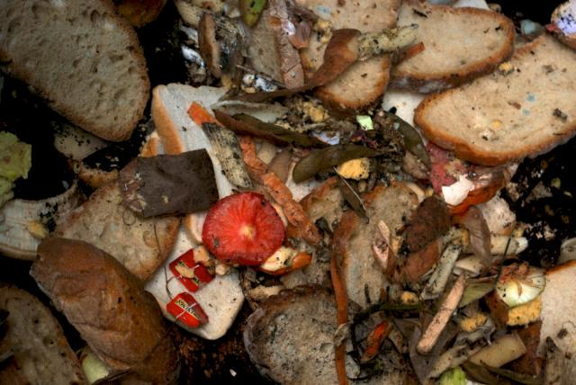

*Food organics (Hyder)*

The following characteristics of food organics collection should be noted when making assumptions about what can be achieved in your council area:

* Refuse collection frequency is a statistically significant factor in the performance of food organics collections. Areas with fortnightly collections of refuse have higher weekly food organics participation and yields.
* Participation and yields can decline over time in areas with weekly refuse collections, while in areas with fortnightly refuse collections yield and participation tends to be maintained.
* Food organics yields may be influenced by the size of the bin provided for refuse.
* Higher food organics yields will generally be found in more affluent areas.

**Garden organics**

The proportion of garden organics in household waste is an important factor influencing collection strategies. Key issues to consider when evaluating how much garden organics will be presented for collection include:

* Proportion of properties with gardens – many urban councils have high proportions of housing stock with either no gardens (such as multi-unit dwellings), or small gardens, where a separate garden waste collection service may deliver small amounts of garden organics.
* Garden size – properties with larger gardens will be expected to produce more garden materials.
* Seasonality – garden organics volumes usually increase in spring/summer/autumn and reduce in winter. On the other hand, food organics shows little seasonal variation.

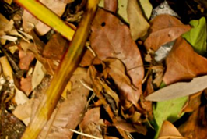

*Garden organics (Hyder)*

Participation in free garden organics collections can be high. Councils that do not currently collect garden organics should therefore be wary of basing predictions of garden organics tonnages on levels currently in the garbage stream alone.

Many councils have experienced additional garden organics being drawn into the collection system when kerbside organics collections are introduced. This may increase the recycling rate, but it will also lead to higher total waste arisings.

Available figures on average yields from Australian households show that garden organics collections can capture 7kg/hh/week in urban areas and up to 10kg/hh/week in rural areas. The following table provides a more detailed recovery statistics for garden organics for several subsamples reviewed as part of the ten Australian kerbside organics collection trials and services.

|  |  |
| --- | --- |
| **Garden organics yields (kg/hhld/week)** | **Average of subsamples** |
| Yield (in a combined food and garden collection service) | 7.7 |
| Yield (SUDs) | 9.4 |
| Yield (MUDs) | 2.5 |
| Yield (weekly collection) | 7.6 |
| Yield (fortnightly collection) | 7.8 |

**Case Study – Resource GV waste audits**

Resource GV is a regional waste management group in Victoria’s Goulburn Valley Region with member councils of Campaspe Shire, City of Greater Shepparton, Mitchell Shire, Moira Shire, Murrindindi Shire and Strathbogie Shire. The organisation engaged a consultant (WasteMin) to conduct comprehensive domestic waste audits in 2010 in order to compare changes from the 2007 audits and identify options for reducing the disposal of organics to landfill.

Councils in the region provide, in general, a weekly 120 litre Mobile Garbage Bin (MGB) service for garbage and fortnightly 240 litre MGB service for recyclables. Nillumbik Council also offers a weekly food and garden collection service in a 120 litre MGB; however the other councils in the region did not offer a regular kerbside organics at the time of the audit.

The audit methodology was based on a random selection of 555 residential dwellings in a representative cross-section of communities in each municipality. Between 55 and 100 bins were sampled in each locality selected. A total of 6,163kg of garbage was audited, with data collected per bin sampled and recorded in grams.

The detailed dataset was analysed to provide information on the best potential areas to target for collection services, education programs and other resource recovery approaches.

Data was presented in several main forms such as:

1. An overall profile of the total garbage, recycling and organics bin contents for each area or subgroup (example shown in Figure 1)
2. A breakdown of sub-categories by weight and volume within recyclables or food and garden organics (example shown in Figure 2)
3. A graphical comparison of composition by weight between the 2007 and 2010 audits, to indicate improvements and other trends for each council area
4. A graphical comparison of the garbage stream and subcategories by weight between the region’s six council areas, to indicate materials with lower than average resource recovery rates in each council area.

**Figure 1 – Resource GV region garbage composition 2010**

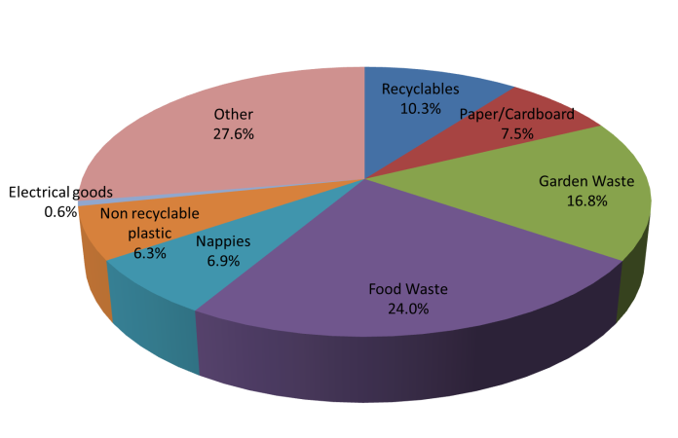

**Figure 2 – Breakdown of food organics in garbage bin**

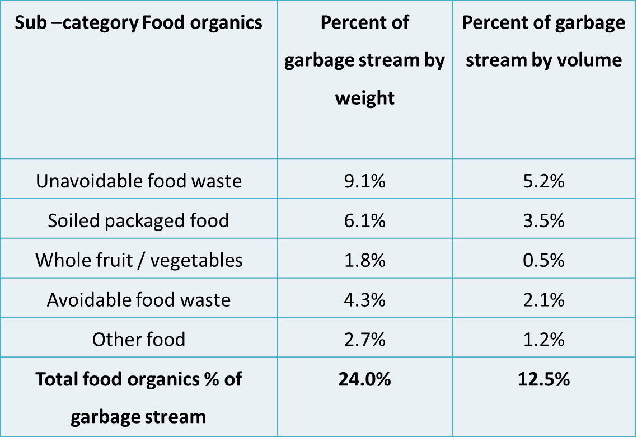

**Lessons Learnt:** One of the key findings of the Resource GV audit series was the higher than average disposal of food and garden organics in the areas of Campaspe Shire and Moira Shire (Factsheet 11), which convinced these councils to consider options for new collection services and promotion of composting. Since that time, both councils have conducted pilot food and garden organics collections, and at the time of publication were considering a move towards full implementation of these services. The Moira pilot trial resulted in an additional 23% diversion from the garbage bin.

NB: Information in this factsheet is taken from the *Food and Garden Organics Best Practice Collection Manual* (2012) published by the Department of Sustainability, Environment, Water, Population and Communities. The full document is available on the department’s website [www.environment.gov.au/wastepolicy/publications/organics-collection-manual](http://www.environment.gov.au/wastepolicy/publications/organics-collection-manual)



*Kerbside-collected garbage ready to be audited*

1. Note that there were three ‘food-only’ subsamples and four subsamples of MUDs included in the review
2. Food organics figures from the Groundswell project are excluded due to the inclusion of Goulburn-Mulwaree monthly collection frequency which resulted in low yields of food